**Easy ultrasonic 4-pin sensor monitoring (hc-sr04)**

[[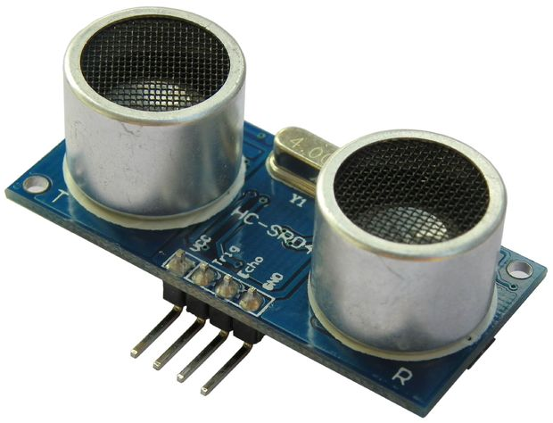](http://cdn.instructables.com/F90/JYNW/H7UR7RCS/F90JYNWH7UR7RCS.LARGE.jpg)](http://cdn.instructables.com/F90/JYNW/H7UR7RCS/F90JYNWH7UR7RCS.LARGE.jpg)

[[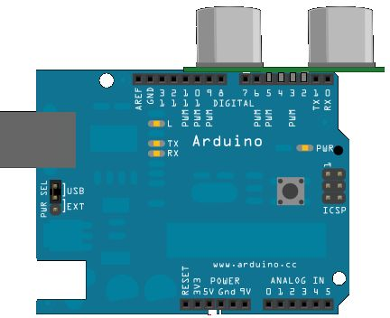](http://cdn.instructables.com/FG5/LWAI/H7UR7RFN/FG5LWAIH7UR7RFN.LARGE.jpg)](http://cdn.instructables.com/FG5/LWAI/H7UR7RFN/FG5LWAIH7UR7RFN.LARGE.jpg)

hello Instructables,  
I have had some trouble with my cheap ultrasonic sensor (hc-sr04) and today I found a really easy solution.  
It is a really simple edit of the normal 3pin code.  
  
  
The new code(4pin):  
  
void setup() {  
  pinMode (2,OUTPUT);//attach pin 2 to vcc  
  pinMode (5,OUTPUT);//attach pin 5 to GND  
  // initialize serial communication:  
  Serial.begin(9600);  
}  
  
void loop()  
{  
digitalWrite(2, HIGH);  
  // establish variables for duration of the ping,  
  // and the distance result in inches and centimeters:  
  long duration, inches, cm;  
  
  // The PING))) is triggered by a HIGH pulse of 2 or more microseconds.  
  // Give a short LOW pulse beforehand to ensure a clean HIGH pulse:  
  pinMode(3, OUTPUT);// attach pin 3 to Trig  
  digitalWrite(3, LOW);  
  delayMicroseconds(2);  
  digitalWrite(3, HIGH);  
  delayMicroseconds(5);  
  digitalWrite(3, LOW);  
  
  // The same pin is used to read the signal from the PING))): a HIGH  
  // pulse whose duration is the time (in microseconds) from the sending  
  // of the ping to the reception of its echo off of an object.  
  pinMode (4, INPUT);//attach pin 4 to Echo  
  duration = pulseIn(4, HIGH);  
  
  // convert the time into a distance  
  inches = microsecondsToInches(duration);  
  cm = microsecondsToCentimeters(duration);  
   
  Serial.print(inches);  
  Serial.print("in, ");  
  Serial.print(cm);  
  Serial.print("cm");  
  Serial.println();  
   
  delay(100);  
}  
  
long microsecondsToInches(long microseconds)  
{  
  // According to Parallax's datasheet for the PING))), there are  
  // 73.746 microseconds per inch (i.e. sound travels at 1130 feet per  
  // second).  This gives the distance travelled by the ping, outbound  
  // and return, so we divide by 2 to get the distance of the obstacle.  
  // See: http://www.parallax.com/dl/docs/prod/acc/28015-PING-v1.3.pdf  
  return microseconds / 74 / 2;  
}  
  
long microsecondsToCentimeters(long microseconds)  
{  
  // The speed of sound is 340 m/s or 29 microseconds per centimeter.  
  // The ping travels out and back, so to find the distance of the  
  // object we take half of the distance travelled.  
  return microseconds / 29 / 2;  
}

## Step 1: 3-pin code

[[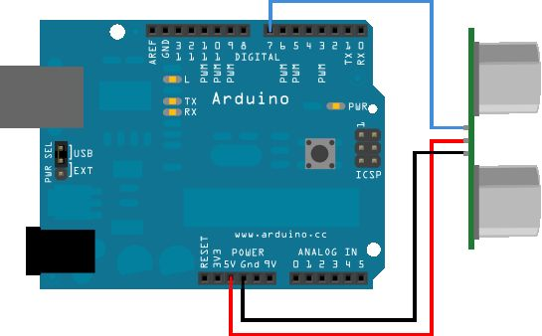](http://cdn.instructables.com/FCG/RWVV/H7UR7RGD/FCGRWVVH7UR7RGD.LARGE.jpg)](http://cdn.instructables.com/FCG/RWVV/H7UR7RGD/FCGRWVVH7UR7RGD.LARGE.jpg)

Code  
/* Ping))) Sensor  
   
   This sketch reads a PING))) ultrasonic rangefinder and returns the  
   distance to the closest object in range. To do this, it sends a pulse  
   to the sensor to initiate a reading, then listens for a pulse  
   to return.  The length of the returning pulse is proportional to  
   the distance of the object from the sensor.  
      
   The circuit:  
    * +V connection of the PING))) attached to +5V  
    * GND connection of the PING))) attached to ground  
    * SIG connection of the PING))) attached to digital pin 7  
  
   http://www.arduino.cc/en/Tutorial/Ping  
    
   created 3 Nov 2008  
   by David A. Mellis  
   modified 30 Aug 2011  
   by Tom Igoe  
  
   This example code is in the public domain.  
  
*/  
  
// this constant won't change.  It's the pin number  
// of the sensor's output:  
const int pingPin = 7;  
  
void setup() {  
  // initialize serial communication:  
  Serial.begin(9600);  
}  
  
void loop()  
{  
  // establish variables for duration of the ping,  
  // and the distance result in inches and centimeters:  
  long duration, inches, cm;  
  
  // The PING))) is triggered by a HIGH pulse of 2 or more microseconds.  
  // Give a short LOW pulse beforehand to ensure a clean HIGH pulse:  
  pinMode(pingPin, OUTPUT);  
  digitalWrite(pingPin, LOW);  
  delayMicroseconds(2);  
  digitalWrite(pingPin, HIGH);  
  delayMicroseconds(5);  
  digitalWrite(pingPin, LOW);  
  
  // The same pin is used to read the signal from the PING))): a HIGH  
  // pulse whose duration is the time (in microseconds) from the sending  
  // of the ping to the reception of its echo off of an object.  
  pinMode(pingPin, INPUT);  
  duration = pulseIn(pingPin, HIGH);  
  
  // convert the time into a distance  
  inches = microsecondsToInches(duration);  
  cm = microsecondsToCentimeters(duration);  
   
  Serial.print(inches);  
  Serial.print("in, ");  
  Serial.print(cm);  
  Serial.print("cm");  
  Serial.println();  
   
  delay(100);  
}  
  
long microsecondsToInches(long microseconds)  
{  
  // According to Parallax's datasheet for the PING))), there are  
  // 73.746 microseconds per inch (i.e. sound travels at 1130 feet per  
  // second).  This gives the distance travelled by the ping, outbound  
  // and return, so we divide by 2 to get the distance of the obstacle.  
  // See: http://www.parallax.com/dl/docs/prod/acc/28015-PING-v1.3.pdf  
  return microseconds / 74 / 2;  
}  
  
long microsecondsToCentimeters(long microseconds)  
{  
  // The speed of sound is 340 m/s or 29 microseconds per centimeter.  
  // The ping travels out and back, so to find the distance of the  
  // object we take half of the distance travelled.  
  return microseconds / 29 / 2;  
}